**Project Design Phase-II**

**Data Flow Diagram & User Stories**

|  |  |
| --- | --- |
| Date | 28 June 2025 |
| Team ID | LTVIP2025TMID36031 |
| Project Name | **Revolutionizing Liver Care: Predicting Liver Cirrhosis Using Advanced Machine Learning Techniques** |
| Maximum Marks | 4 Marks |

**Data Flow Diagrams:**

A Data Flow Diagram (DFD) is a traditional visual representation of the information flows within a system. A neat and clear DFD can depict the right amount of the system requirement graphically. It shows how data enters and leaves the system, what changes the information, and where data is stored.

**Example:** [**(Simplified)**](https://developer.ibm.com/patterns/visualize-unstructured-text/)

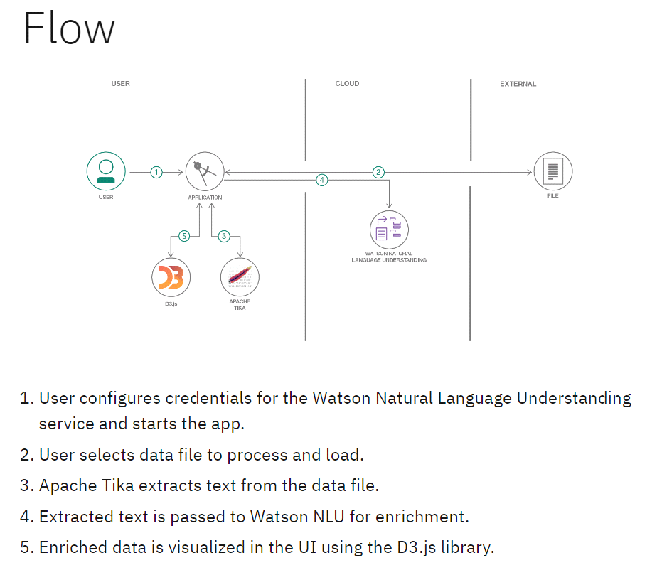

**User Stories :**

|  |  |  |  |  |  |
| --- | --- | --- | --- | --- | --- |
| User Type | Functional Requirement (Epic) | User Story Number | User Story / Task | Acceptance Criteria | Priority |
| Patient | Registration | USN-1 | As a patient, I can register using email and password. | Account is created and accessible. | High |
| Patient | Registration | USN-2 | As a patient, I can register via Google login. | Can access dashboard using Google login. | Medium |
| Patient | Data Input | USN-3 | As a patient, I can manually enter my medical history. | System accepts and stores data. | High |
| Patient | Data Upload | USN-4 | As a patient, I can upload lab reports or medical files. | Files are uploaded and analyzed. | High |
| Patient | Dashboard | USN-5 | As a patient, I can view prediction results and recommendations. | Reports and advice are displayed. | High |
| System | ML Prediction | USN-6 | As a system, I can analyze uploaded data using ML model. | Prediction results are generated. | High |